PhotoShop Projects
Summer MBEA Conference 2013
Presenter – Theresa Taylor, Cape Central High School
taylort@capetigers.com
Photoshop – Custom Color on Black and White Picture

- Open Addison.
- Edit / New Adjustment Layer / Black and White
- In case you plan to print, let’s look at the size of the picture. Click Image / Image size or Ctrl + Alt + I, look at the size of the picture.
- Make sure you are on the black and white layer. You could use a brush and paint black over the skirt. Or you can use the quick selection tool to select the skirt and fill black.

Creating Scrapbooking Pages

- New file 12 x 12, white background save as Granddaughters.
- Open flowers and add adjustment layer, change hue to +17, Saturation to -22 and lightness to -21
- Use shift to select both layers and Move to original picture, merge two layers
- Ctrl +t, resize to cover all of picture and move to right so most flowers are used. Accept when finished
- Text layer, Type Grand Daughters, double click on text thumbnail,
    - Color – purple, size – 72, French Script MT, Strong
    - Add drop shadow and adjust distance spread and size until happy.
- Use move tool to move to lower right corner and Accept.
- Draw a heart, open Addison and Chloe, move over heart, rename the layer “girls”.
- Select the heart and girls layers and clip (alt + click between layers)
- Click on Girls layer, Ctrl + T (transform tool) hold shift and drag from the corner until you are happy. Click Enter to accept the changes.
- Draw star shape, open Chloe and move into picture, hold shift and click two layers, hold alt and click between layers to clip, Ctrl + T to reposition and resize picture to fit shape, click enter when happy
- Open green butterfly, select white, select inverse, move to picture, Ctrl + T to resize. Move to upper right corner, name layer green butterfly, duplicate layer twice, name the other two layers orange butterfly and pink butterfly. Arrange butterflies in upper right hand corner. Select orange layer, change foreground color to orange, choose the paint bucket and click on butterfly. Repeat to pink butterfly using pink color.
- Open purple butterfly, select background, select inverse, select and move to new picture, click fx for blend mode and make settings
- Open Addison, use polygonal selection tool to draw around her, move to new picture.
- Drag purple butterfly layer above Addison layer.
- Apply drop shadow and outer glow.
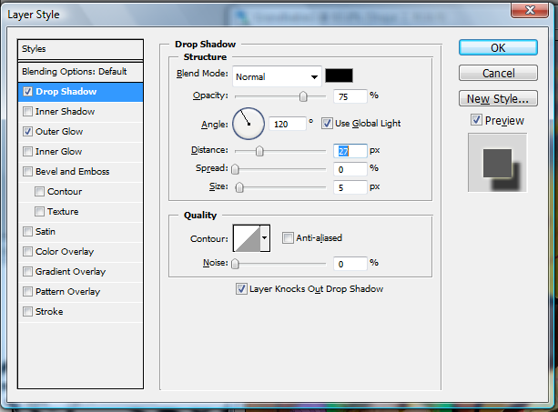
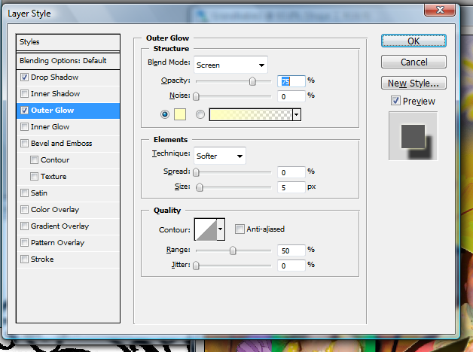

Save

Scrapbooking pages – Scoring Guide
You will create two scrapbooking pages
Each page must
- Be 12 inches by 12 inches
- Must include a title
- Must include at least one other set of text
- Must include at least three pictures
- Between the two pages there must be at least three pictures that include a clipping mask where they are clipped to a shape
- Each page needs additional borders, shapes, and decorations (flowers, balls, butterflies, etc)
- There must be a theme to the page, not just random pictures and graphics
- One page must have a picture background (plaid, horses, starry sky, etc)
- One page must be a solid color or gradient and the colors must have been eyedropped from one of the pictures.

Scoring Sheet
 | Points Possible | Points and Comments
Each page is 12 inches by 12 inches | 2
Each page includes a title, custom font, color, size and effects | 5
Each page must include at least one other set of text
Each page must include at least three pictures | 6
Between the two pages there must be at least three pictures that include a clipping mask where they are clipped to a shape; at least one needs an effect applied | 6
Each page needs additional borders, shapes, and decorations (flowers, balls, butterflies, etc) | 6
Each page There must be a theme to the page, not just random pictures and graphics | 4
One page must have a picture background (plaid, horses, starry sky, etc) | 2
One page must be a solid color or gradient and the colors must have been eyedropped from one of the pictures. | 2
Creativity and Effort | 4
Total Points | 30

Copyright Watermark
- Open Addie from the Watermark folder.
- Select the type tool and type the text you want to use for a watermark.
- While you're still in the type tool dialog, click the color swatch, and set the color to 50% gray. (Use HSB values 0-0-50 or RGB values 128-128-128; both will produce the same result).
- Click OK to exit the type tool.
- Resize and position your text as desired.
- Apply the Bevel and Emboss effect and adjust the setting until it's to your liking.
  - Photoshop 5 click the fx in the layers palette.
  - Photoshop 5.5: Right click (Mac users control-click) on the type layer in the layer palette and choose Effects.
  - Photoshop 6 and 7: Double click on a blank area of the type layer in the layer palette (not the thumbnail or the layer name) to bring up the layer styles dialog.
- In the layers palette, change the blend mode for the type layer to Hard Light.
- Tips:
- If you'd like the watermark a little more visible, try a color value of 60% gray for the type (HSB value 0-0-60).
- Resize the type at any time by pressing Ctrl-T (Windows) or Command-T (Mac). Hold the shift key and drag a corner handle. When you apply the transformation, the type will resize with no loss in quality.
- You are not restricted to using only text for this effect. Try importing a logo or symbol to use as a watermark.
- The Windows keyboard shortcut for the copyright (©) symbol is Alt+0169 (use the numeric keypad to type the numbers). The Mac shortcut is Option-G.
- If you use the same watermark often, save it to a file that can be dropped into an image any time you need it. Remember, it's always editable!

Make a Photo into a Collage of Squares
- Open Kids in Hammock.
- Duplicate the background (control +J)
- Add new transparent layer between the two layers, fill this layer with white. Click D to reset foreground color. Ctrl + Backspace to fill layer white. (other option is Edit > Fill > white). Nothing happens in the picture but the layer thumbnail turns white.
- Select your copy of the background and choose the Rectangular Marquee tool, hold down your shift key to keep it square and drag out over the guy’s face.
- Make sure you are on Layer 1 and click the Add Layer Mask.
- Unlink the mask from the layer by clicking the “link” between the two.
- So we can see the edges of the square we will add and Outer Glow layer style. Click directly on the mask’s thumbnail so it is selected. Click the New Adjustment Layer icon found at the bottom of the layers palette and choose Outer Glow.
- Click the color picker in the dialog box and choose white.
- Leave all the other settings at the defaults.
- Duplicate Layer 1.
- Drag the mask to a new location.
- Continue to duplicate and move over the main part of the picture (25-30 times)
- Duplicate layer and use the transform tool (ctrl + T) to shrink it to about 50% and move to an appropriate location.
- Duplicate newest layer and move to new location and repeat about 10 times.
- Duplicate newest layer use the transform tool (ctrl + T) to shrink it to about 50% and move to an appropriate location.
- Duplicate newest layer and move to appropriate location, repeat 5-10 times.
- Merge all mask layers, so everything but the background and layer 2. Click on the top layer, scroll down to layer 2, hold shift and click on layer 2. Ctrl + E will merge them or right click.
- Click on the New Adjustment Layer icon and choose drop shadow and change the opacity to 25.
- Save and you are done.

“You Crack Me Up” Egg Decorating Photoshop Project
You will be giving eggs personality using the “Cute Faces” brush in Photoshop. Follow the steps below to complete the project:
Before you begin, create a folder and name it Photoshop Egg. Find random pictures of eggs on the internet and one picture of an empty egg carton. Save the pictures in the folder you created.
- Open Photoshop and create a new document; type in Eggs for the document name, choose preset: Custom, and change the resolution to 150. Make sure the Color Profile is not set to Grayscale (Choose RGB).
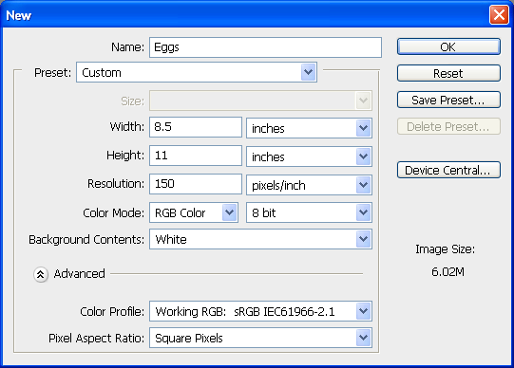

- Make sure Auto Select and Show Transform tools are NOT checked. Load the “Cute Faces” brushes (you must select the paint brush tool first). You will need to browse to the location the brushes are saved in: I:/A Winship/Photoshop

- Open the picture of the egg carton (File, Open). Restore down so both documents are side by side. Select the egg carton with the selection tool of your choice (try the Quick Selection tool). Once it is selected, switch to the Move tool and drag to your blank (original document). You no longer need the original egg carton document you opened (you can close or minimize). HINT: If the picture is too large, select Edit, Free Transform and resize. Remember you must either accept or cancel the size change before you can move on. Name the Layer carton.

- Open one of your egg pictures in Photoshop (preferably a plain egg as this will serve as the back row and will be faceless). Repeat the steps above and add to the document with the egg carton; select, move, resize using Edit, Free Transform.

- Copy the layer five times to give you the back row of eggs. You can either right click and duplicate or hold down the Alt key and click/drag the object you wish to copy. It’s very important to name layers appropriately – this way you know which layer you are working on at any given time.

- Click on the Create a New Group folder (bottom of the Layers palette) and drag all of the egg layers into the folder.

- Open six different egg pictures (one at a time) and select, move, and resize. These are the eggs you will use the brush tool to paint faces on. Click on the paint brush tool and select a different face for each one – you will need to change the brush size to fit the faces on the eggs. You can do this by changing the pixel size or clicking on the left bracket.

- Now that we have gone through some Photoshop basics together your assignment is to create something unique using the same concepts. See the attached pictures for ideas. There are more examples on the I: Drive. You must use at least four different styled eggs with four different faces. Be creative!!! BREAK AN EGG!

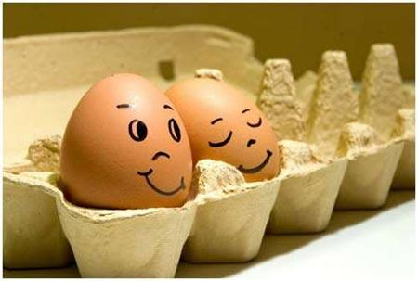
Objectives:
- Utilize the Quick Selection tool
- Utilize the Move tool
- Load and use custom paint brushes
- Create and name layers
- Group layers
- Resize using Edit, Free Transform
- Rotate pictures
- Manipulate layers to change order of objects
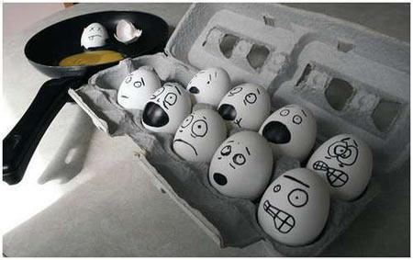
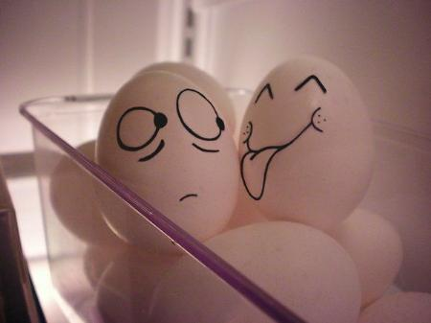

You will be graded on the following:
Four different egg pictures were used and sized appropriately __________/16
Different faces were used for each egg __________/ 4
Scene and creativity (different objects incorporated into project) __________/ 5
TOTAL __________/25

Online tutorials and YouTube Videos
Tonya Skinners Screencasts
http://lessonplans.btskinner.com/screencasts.html
Turn Yourself into a Zombie
http://www.photoshoplady.com/tutorial/turning-yourself-into-a-zombie/6638

Avatar
http://www.photoshoplady.com/tutorial/awesome-avatar-transformation-using-photoshop/2661
one we used
http://www.photoshoplady.com/tutorial/awesome-avatar-transformation-using-photoshop/2661
Faking Text wrapping
http://photoshopessentials.com/photoshop-text/text-effects/text-wrap/
Ice Text Affect
http://www.webdesign.org/photoshop/photoshop-cs5-tutorials/simple-ice-text-effect.21161.html
Ribbon text
http://www.webdesign.org/photoshop/photoshop-cs5-tutorials/3d-ribbon-wrapped-text-effect.21082.html

Retro Text Affect
http://www.webdesign.org/photoshop/text-effects/colorful-retro-text-effect.20262.html

Tons of tutorials and you can pick from CS4, CS5 or CS6
http://www.webdesign.org/photoshop/tutorials/page-1.html

Video on Patch Match
http://www.webdesign.org/photoshop/photoshop-cs5-tutorials/patchmatch-feature-in-photoshop-cs5.18219.html
Video explaining Content Aware
http://www.webdesign.org/photoshop/photoshop-cs5-tutorials/content-aware-fill.18220.html

Tips and Tricks
All these commands are tested in Photoshop CS5. Some of them works in previous versions of the program too.
- 1. When no file is opened, double click the gray background area and the "Open" command will run.
- 2. When you press the TAB the toolbar and panels will hide. Shift + Tab will hide only the panels.
- 3. Pressing Ctrl+Tab will toggle between all opened image files.
- 4. Double clicking on the title of any panel will minimize or maximize it.
- 5. Pressing Ctrl+J will make a duplicate layer.
- 6. Ctrl+E will merge all selected layers.
- 7. Ctrl+Shift+N creeates new layer with a dialog box, Ctrl+Shift+Alt+N creates a new layer, with no questions asked.
- 8. Pressing X will swap the foreground and background colors.
- 9. Pressing D will resets the foreground and background colors to default.
- 10. Holding Spacebar will temporarily change you current tool to Hand Tool.
- 11. Holding Ctrl will change you current tool to Move Tool until you release it.
- 12. If you want to show or hide a path, you can do it by pressing Ctrl+shift+H.
- 13. Press Ctrl + D to deselect everything, and Ctrl+Shift+D to reselect what you deselected.
- 14. When file is opened, press F to switch between program layout modes.
- 15. This works only if file is opened. If you want to change the gray background color around the opened file, select Paint Bucket tool, hold shift and click.
- 16. In Photoshop CS5 when you want to draw a perfect straight line, click at the point where you want your line to start, then hold Shift and Click on the point where you want your line to end.
- 17. Alt + Mouse Scroll will change the zoom level.
- 18. Holding Alt will temporarily change you current tool to Eyedropper Tool, if you are working with a painting tool.
- 19. When you are using Magnetic Lasso Tool, pressing Delete button will remove the last anchor point (this one is very useful for me).
- 20. Pressing Caps Lock will switch your cursor to Plus sign for precision painting.
- 21. When double click the Hand Tool you will get the largest full image preview possible.
- 22. When you are using the Eyedropper Tool to capture foreground color, hold Alt and click to capture the color for background.
- 23. While using the Zoom Tool, press Ctrl + Spacebar to zoom in, Alt + Spacebar to zoom out.
- 24. Double clicking the Zoom Tool will set the zoom level to 100%.
- 25. Alt drag a step from a serial action can copy it to another action.
- 26. If you hold down Alt while using Burn or Dodge Tool, it switches the tool functions in between them.
- 27. Hold Shift and press "+" or "-" it will change the layer and painting modes:
N = Normal
I = Dissolve
M = Multiply
S = Screen
O = Overlay
F = Soft Light
H = Hard Light
D = Color Dodge
B = Color Burn
K = Darken
G = Lighten
E = Difference
X = Exclusion
U = Hue
T = Saturation
C = Color
Y = Luminosity
Q = Behind 1
L = Threshold 2
R = Clear 3
W = Shadow 4
V = Midtones 4
Z = Highlights 4
- 28. When you Ctrl + Alt + Click and drag the image, it will create a duplication of the current image or selection and make an overlay on top.
- 29. If you have to import an object from Illustrator to Photoshop, just Copy and Paste it. Photoshop CS5 will ask you to import it as a vector or bitmap.
- 30. When you are drawing a line with the Measure Tool, if you hold Alt and draw another line from the end of the first one, it will also measure the angle.
- 31. Ctrl + Backspace and Alt + Backspace will fill the whole image area with foreground or background color.
- 32. When you are done typing with the text tool, press Ctrl+Enter and the program will know you are done.

